Access to Statewide Course Numbering System(SCNS) is through Florida Department of Education Single Sign-On (FLDOE SSO) for Florida State Colleges, Universities, Career Technical Centers and approved private colleges. These Institution Contact accounts are responsible for submitting their college course information.
1. Florida State College, Universities, Career and Technical Center and approved private college Users
1.1 Contact your ‘District/Florida State College/University LEA’/SCNS to get you added to the FLDOE SSO.
1.2 Once added, go to the FLDOE SSO Portal, and select Educators to begin the login process.
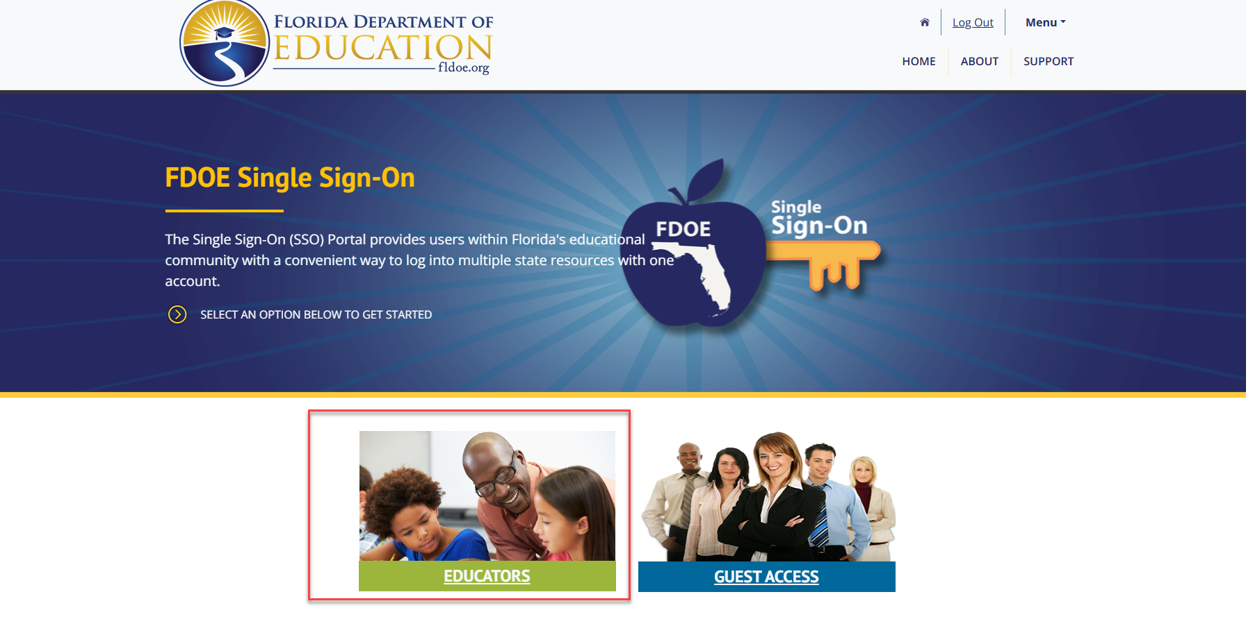

1.3 On the FLDOE SSO sign-in page, select your designated district/Florida State College/University/private college from the list to proceed.

1.4 Enter your Active Directory Username and Password to authenticate.
1.5 Once authentication is complete, you will land on the application’s Welcome page. If you have multiple user accounts linked to the same email ID, all associated applications will appear on this screen.

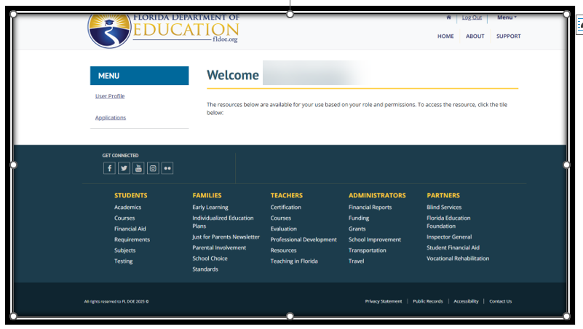
  - To access your intended application, you will either need to contact the application administrator for access or click the application tile and follow the on-screen instructions—depending on how access is managed for that specific application.

2. Existing District/Florida State College, University, Career and Technical Center and approved private college Users (Having FLDOE SSO Account)
2.1 Go to the FLDOE SSO and click Educators
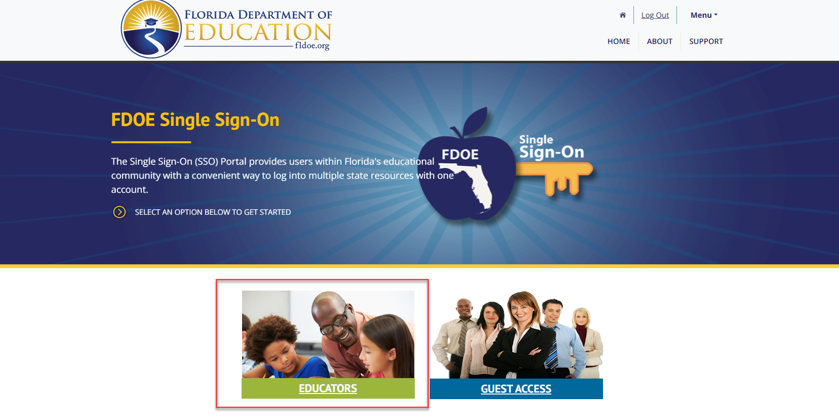
2.2 On the FLDOE SSO sign-in page, select your designated district/Florida State College, University, Career and Technical Center or approved private college from the list to proceed.

2.3 Enter your Active Directory Username and Password and complete the authentication.
2.4 Once authentication is complete, you will land on the application’s Welcome page. If you have multiple user accounts linked to the same email ID, all associated applications will appear on this screen.
2.5 To access your intended application, you will either need to contact the application administrator for access or click the application name or icon shown on the screen above and follow the on-screen instructions to access the application.

